ISyE 7406

Team Name: Team 5 (Sticky Joe)

Final Report for Semester Project

|  |  |
| --- | --- |
| Team Member Name: | Role: |
| Joshua Cantera | Model Construction, property assessment |
| Samuel Courson | Literature Review, Data Collection, Front-end |
| Andrew Crawford | Data Collection and cleaning, modeling, property assessment, front-end visualization, web server |
| Joseph Geibig | Data Exploration and model construction |
| Mehmet Gunerli | Literature Review, Collection and Processing of Stops Data, Python Network Maps and Visualizations |
| Nihal Kakkatil | Model construction, conclusion and future work |
| Nikolaos Kavouras | Model building, data exploration |
| Zachary Labkovski | Introduction, model building |
| Mark Ramirez | Property Assessment, Front-end |

Abstract:

In this report, we detail our processes for collecting and cleaning data, training a model, and outputting a visual map to predict delays along MARTA’s train lines. We outline the steps taken, along with the code used to generate the outputs. We show some example output generated by our function and demonstrate how the Flask server map visualization works. We also go through shortcomings related to our work and look at potential future topics which could be further explored as part of the project.

Table of Contents

Introduction……………………………………………………………………………………......3

Literature Review………………………………………………………………………………….4

Data Collection……………………………………………………………………………………6  
Proposed Methods………………………………………………………………………………..11  
Data Modeling and Results……………………………………………………………………....13

Property Evaluation……………………………………………………………………………...23

Front-end Visualization………………………………………………………………………….26  
Conclusion and Future Work…………………………………………………………………….31  
References………………………………………………………………………………………..35  
Appendix…………………………………………………………………………………………37

1. Introduction

Despite being one of the nation’s largest metropolitan transportation systems, MARTA continues to operate sub optimally, both in its internal operations and in providing information to riders. While improvements to MARTA’s internal operations cannot be made using publicly available data, there are ways to improve user experience by implementing predictive modeling, which would allow for users to plan trips further in advance rather than relying on real time delay information.

Fortunately, MARTA allows for public access to transit data with their API, found [here.](https://www.itsmarta.com/app-developer-resources.aspx) In accessing the API, we were able to extract data including destination, transit line, time of day, and day of week for each “event” in the transportation system. This data can be utilized in a variety of models to predict both probability of delay for a specific MARTA line and expected length of delay.

Overall, our goal in this project was to create an efficient, informative, and user-friendly application that truly provides value to Atlanta area commuters and travelers. This is differentiable from currently available applications that do not contain the predictive power and information we sought to encompass. Our approach was altogether unique from those attempted in the past, which we felt would allow for much more useful results.

In order to develop a model that maximized the value provided to potential users, we decided to implement a variety of approaches. Our main goals were to predict relatively far in advance whether a specific train would be delayed and by how much. A few approaches we initially sought to implement are binary logistic regression, generalized linear model, tree-based models, and neural networks. In the end, we settled on logistic regression, random forest, and gradient boosting classifier models to implement before comparing to determine which one is most effective for our desired prediction.

1. Literature Review

Transportation systems are a critical component of modern cities, and optimizing their performance is a key challenge for urban planners and policymakers. In recent years, the use of machine learning algorithms, like neural networks and gradient boosting models, has shown promise in improving the accuracy of predicting transportation delays in rapid rail transit systems like Atlanta's MARTA.

Bollinger and Ihlanfeldt (1997) found that MARTA has had a positive impact on economic development in the Atlanta area, particularly in terms of increasing property values and spurring commercial development. In addition, Macfarlane et al. (2014) investigated the willingness of Atlanta residents to pay for MARTA services and found that residents place a high value on MARTA's services. Further investigating MARTA's impact, Tucker (2005) explored the expected increase in ridership due to proposed MARTA expansions and found that the expansions are expected to significantly increase ridership.

Peters et al. (2005) explored the use of neural networks for predicting delays in public transportation systems. While Peters did not specifically focus on boosting models, his research highlights the potential of machine learning algorithms for improving transportation delay predictions. Shoman et al. (2020) similarly explored the use of artificial neural networks (ANN) within a deep learning framework for network-level predictions of bus delays in the city of St. Louis, ultimately arriving at a mean absolute prediction error (MAPE) value of less than 6%. The study explores the relative effects of factors such as varying station distances, traffic congestion, peak hours and holiday travel patterns using real-time traffic data.

In the area of boosting models, recent literature has found that Gradient Boosting Machines (GBMs) are an effective approach for predicting transportation delays (Gupta and Shrestha, 2017; Yener and Ercan, 2019). GBMs have been shown to improve prediction accuracy by effectively modeling complex non-linear relationships between input features and output variables. Zhang and Haghani (2015) similarly explored GBMs alongside other alternative models such as Autoregressive Integrated Moving Average (ARIMA) and Random Forest (RF) in improving travel time prediction by accurately modeling the underlying freeway traffic conditions using historical travel time data. While parameter optimization proved difficult, it was concluded that the final GBM model outperformed all other alternatives MAPE as a measure. Similarly, effective feature selection and engineering along with parameter optimization are crucial steps in developing accurate boosting models for transportation systems (Yener and Ercan, 2019). Lastly, Antypas et al. (2022) similarly employed various Gradient Boosting (GB) techniques for predicting estimated time of arrival (ETA) while engaging with the incoming impact of autonomous vehicles’ (AV) in public transportation.

As we also explored in our project, real-time data sources, such as weather and traffic data can be incorporated into boosting models to further improve accuracy and predictive capabilities (Gupta and Shrestha, 2017). Additionally, explainable AI techniques, such as SHAP values, can be used to improve model interpretability and identify the most important features for predicting transportation delays (Yener and Ercan, 2019).

As part of our study, user interface (UI) design was another important factor to consider. Our approach consisted of balancing between looks and usability, which necessitated that a happy medium was established between developing a proprietary feature-packed python visualization from scratch that may have lacked in user-friendliness and adopting a widely-used and popular tool like Tableau, We studied alternative stylings compiled by Avelar (2008) for the city of Zurich and focused on various characteristics such as design elements, map styles, mode of transport, demographics of the end-user and interactivity. Similarly, we were inspired by the work of Zheng et al. (2014) on designing effective visualization methods of complex public transportation systems and incorporation of time-oriented data was influential in our design choices. The visualizations explored as part of the study such as isotime flow and isochrone maps, along with the OD-pair journey view turned out to be redundant in terms of complexity, they still served as useful starting points in developing our own visualizations and user interface.

Lastly, understanding the economic and social impacts of transit systems, such as those explored by Bollinger and Ihlanfeldt (1997), Macfarlane et al. (2014), and Tucker (2017), is important for informing transportation planning and policy decisions. By incorporating machine learning algorithms, such as boosting models, policymakers and urban planners can better optimize the performance of transportation systems, leading to more efficient and effective urban transportation.

1. Data Collection

**Data Collection via APIs**

The first of our data sources comes from [MARTA's RESTful API](https://www.itsmarta.com/app-developer-resources.aspx). Using Python's requests library, we can access real-time rail data (in JSON format) which includes variables like current location, destination, train ID, timestamps, and delay time. The delay time is the most important variable from this dataset because we will be using historical delays in an attempt to predict future rail delays. Here is an example of the rail data pulled in as its raw JSON form:

{"RailArrivals":[{"DESTINATION":"AIRPORT","DIRECTION":"S","EVENT_TIME":"2023-02-20T11:16:40Z","HEAD_SIGN":"AIRPORT","LINE":"GOLD","NEXT_ARR":"2023-02-20T12:25:51Z","STATION":"AIRPORT STATION","TRAIN_ID":"311","WAITING_SECONDS":"536","WAITING_TIME":"7 min","RESPONSETIMESTAMP":"2023-02-20T11:11:19Z","VEHICLELONGITUDE":"33.651976","VEHICLELATITUDE":"-84.448918","DELAY":"T70S","TRIP_ID":"3195"},{"DESTINATION":"AIRPORT","DIRECTION":"S","EVENT_TIME":"2023-02-20T11:16:51Z","HEAD_SIGN":"AIRPORT","LINE":"GOLD","NEXT_ARR":"2023-02-20T12:49:19Z","STATION":"AIRPORT STATION","TRAIN_ID":"307","WAITING_SECONDS":"1954","WAITING_TIME":"31 min","RESPONSETIMESTAMP":"2023-02-20T11:11:07Z","VEHICLELONGITUDE":"33.735979","VEHICLELATITUDE":"-84.413779","DELAY":"T201S","TRIP_ID":"3196"}

**Figure 1**: Example JSON format for MARTA API

We have also decided to include real-time traffic data because there is possibly a strong predictive correlation between car traffic and rail delays. We accessed this data using [Google Maps' API](https://developers.google.com/maps). From this data, we can get the time without traffic and time with traffic for a given route. However, it is important to note that Google will eventually start charging after a certain number of pulls from their APIs. With this in mind, we decided to limit our pulls to only accessing the interior spans of I-85 and I-20 ("interior" meaning contained within the I-285 connector). The rail lines closely parallel the routes of these interstates, and they are the two most important arteries in Atlanta's traffic network, so the data from solely these interstates should still carry a high amount of predictive power in terms of rail delays. A sample of the traffic data in its raw JSON format is included below:

{

   "destination_addresses" : [ "I-20, Atlanta, GA 30331, USA" ],

   "origin_addresses" : [ "I-20, Decatur, GA 30032, USA" ],

   "rows" : [

      {

         "elements" : [

            {

               "distance" : {

                  "text" : "26.5 km",

                  "value" : 26473

               },

               "duration" : {

                  "text" : "15 mins",

                  "value" : 903

               },

               "duration_in_traffic" : {

                  "text" : "15 mins",

                  "value" : 878

               },

               "status" : "OK"

            }

         ]

      }

   ],

   "status" : "OK"

}

**Figure 2**: Example JSON format for Traffic API

Like traffic data, it can be reasoned that weather data will also have an effect on rail traffic because commuters may be more likely to take a train rather than other forms of transportation on days when the weather is poor. So, we accessed another API, from [WeatherAPI.com](https://www.weatherapi.com/), to access real-time weather data (also in JSON format) for the city of Atlanta. Variables like temperature, precipitation, and wind speed are available in this API. Below is a sample of one of these weather data pulls:

{"location":{"name":"Atlanta","region":"Georgia","country":"United States of America","lat":33.75,"lon":-84.39,"tz_id":"America/New_York","localtime_epoch":1676909982,"localtime":"2023-02-20 11:19"},"current":{"last_updated_epoch":1676909700,"last_updated":"2023-02-20 11:15","temp_c":16.1,"temp_f":61.0,"is_day":1,"condition":{"text":"Sunny","icon":"//cdn.weatherapi.com/weather/64x64/day/113.png","code":1000},"wind_mph":10.5,"wind_kph":16.9,"wind_degree":250,"wind_dir":"WSW","pressure_mb":1016.0,"pressure_in":30.0,"precip_mm":0.0,"precip_in":0.0,"humidity":58,"cloud":0,"feelslike_c":16.1,"feelslike_f":61.0,"vis_km":16.0,"vis_miles":9.0,"uv":3.0,"gust_mph":11.2,"gust_kph":18.0}}

**Figure 3**: Example JSON format for weather API

We are pulling the MARTA, traffic, and weather APIs once every 10 minutes. This is accomplished using the APScheduler library’s BlockingScheduler function. Every 10 minutes, this function executes a pull and adds to a data frame for each of the 3 APIs. Every 6 hours, the function running the MARTA API pull outputs a CSV file, with the weather and traffic function outputting a csv every 24 hours. This allows us to save our data offline and have a backup should the computer/internet go down. One downside to this is the computer running the function needs to be always on/running the program and cannot be moved in order to retain internet connection. This may result in some potential gaps in the data, should there be an issue with the network connection of the computer.

**Data Cleaning**

Since all our data is provided in a JSON format, it requires extensive cleaning to prepare it for Python packages like pandas and scikit-learn. A lot of the heavy lifting in the cleaning process is carried out by Python's json package as this package can take raw strings in JSON format and convert them to Python dictionaries. An example of this type of conversion step can be seen here:

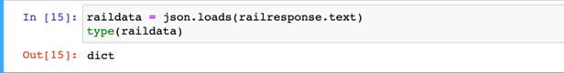

**Figure 4:** Python code for converting JSON rail data

After the data has been processed as a Python dictionary, it is quite easy to convert it to a tabular data frame. Once converted to a data frame, the only cleaning remaining is to drop or tidy up variable names, types, and formats. We had to particularly clean up the time-related data variables so that they are all in a "Y-M-D H:M:S" format. This standardization guarantees that there will not be any time-related errors when running our model.

Our data is being collected and stored in several different files, so combining them into one is necessary. Furthermore, the dates and times are in different formats for different sources of data, so standardizing them is also necessary. The variables in each csv file have already been narrowed down to only what is needed, so we don’t need to remove any unnecessary variables.

Since the MARTA data pull outputs a CSV file every 6 hours, we have many individual files. These will need to be combined into one using pandas. The weather and traffic data outputs a CSV file every 24 hours, so there are fewer files, but we still need to combine the data. Once the data is combined, the date/time can be standardized and the data can be indexed by date/time, allowing for easy use in the models our group will be building later on.

To combine the data, first combined each source of data into one data frame, producing 3 large Tibbles. Then we used tolerance merges in pandas. This was due to the dates and times not aligning perfectly. Tolerance merges allow us to merge when the times are within a specified range, say for instance, rows of table 1 are joined with rows of table 2 when their times are within 4 minutes of each other. After all data was joined into a single data frame, we filtered out any rows containing null values. Since there were a few instances where the data collection lapsed, we had a small ratio of null rows, which made up roughly 4% of the entire dataset. These rows were dropped since we could not train a model on missing data.

**Data Preparation**

To prepare the data for the models and visualizations, a few preparation steps were needed. The first was creating our ‘lag’ in the response variable. This was done by subtracting 7 days from the date for each value of the response variable, then re-joining to the dataset. This allowed us to train the model using the delay data from a week in the future. This step was also done for days 1 through 6, with the intention of formulating 6 additional models to predict delays from 1 to 6 days out. This clean data was then exported as a csv file, so it could be used by the python scripts to train the models. There were a few additional cleaning steps undertaken for each respective model. For example, the gradient boosting classifier required a binary response variable, which meant we had to change our response to a 0 or a 1. Furthermore, the specific predictor variables for the model were selected. This was done after the data was exported as a csv, but it’s still worth mentioning in the cleaning stage.

There were also a few steps needed in order to run the Tableau map. Besides the standard date/time processing, the MARTA API confused longitude and latitude. This silly mistake meant the columns were incorrectly labeled and had to be adjusted to make the Tableau run smoothly. This rather hilarious error on MARTA’s behalf is a microcosm of our experience working with this method of data collection.

1. Proposed Methods

As a team, we have discussed many different models that we could utilize for completing our goal of predicting delays in the MARTA rail system. These models are outlined below, including the potential data requirements and feature engineering that would need to be done to ensure that these models are successful.

**Random Forest Regressor**

The first model we want to try is a random forest regressor to predict delays. Random forests are good for a number of reasons. The first is that random forests are generally very robust and are less prone to overfitting than some other regression methods. They also handle large numbers of variables quite well, which is applicable in our case. They are generally very accurate and work well with non-linear relationships, which, again, is applicable to our case. Random Forests also give us good information regarding feature importance and outliers. Some drawbacks we might see revolve around our highly variable data, and seeing if the random forest is able to effectively capture that variation.

**Gradient Boosting Classifier**

Another method we wanted to look at was a gradient boosting classifier. In this case, we will be doing classification rather than regression, so we will need binary output. We can use a threshold of 60 seconds to separate our 0s and 1s. We would also need to one-hot-encode a number of categorical variables in order to use them in the model. A gradient boosting classifier is an attractive option for several reasons. They can produce extremely accurate results, making them one of the more popular models to use today. They also exhibit a good deal of flexibility, meaning they can work with all types of data, something that we would need in our model. Similar to the random forest, they are very robust, and produce good information on feature importance. Finally, gradient boosting models can be easily tuned, allowing the user to quickly determine the optimal hyperparameters. This method could be very fruitful for our project, especially if the random forest model is unable to handle variation well.

**Implementation**

The main options for implementation will revolve around a website or an app, where a user can input values and return a prediction based on those values. This can be done using a Flask server, which runs python code on a local web server. This would allow a user to input values for the train and line they wish to view, and then display a folium map showing the results of the predictions for their input. Since our model will be making predictions, we can color code the stations on the map based on whether there is a significant delay or not. We can also show the exact probability of a delay, or the estimated delay, should the models give that output.

Besides the web server, we also have a Tableau map dashboard. The Tableau map can show more detail than the python-based folium package can. This map can show all train lines, as well as the location of each train on the line. It can also do color-coding, just as the folium map can. The only downside is the Tableau map cannot be run inside a python function, making it a secondary option for our front-end visualization.

Both are valid implementations of our model and allow a user to visualize the results of the model.

1. Data Modeling and Results

Some initial modeling was done to see if anything could be gained from either a linear or logistic regression, using time delayed as the response. We used just the numeric variables to run the regression, so several variables had to be dropped. The data was segmented by the specific trains to contain any variation caused by the different lines. Here is an example of the code for a logistic regression. The response variable had to be coerced to binary for this model.

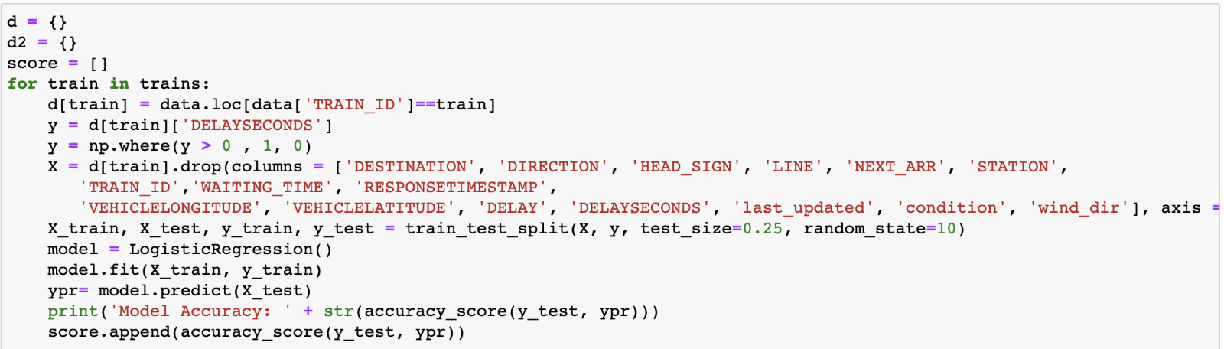

**Figure 5:** Python code for logistic regression on rail data

The results of this model showed accuracies between 55% and 89% for the 30 trains. However, the model over-predicted the number of trains delayed, which increased the accuracies. The linear regression fared worse. The highest R-squared value produced for any of the 30 trains was .22, which means that the numeric variables do not predict delays too well. None of this was particularly surprising, as we suspected we would need more advanced models to predict the delay time for the trains.

Next, we looked at the response variable, the delay for each train in seconds. As shown in the plot below, there are some fluctuations in the delays. The maximum delay is 32,721 seconds, which is over 9 hours. We can investigate further for causes of these fluctuations and what might be causing a delay of over 9 hours.

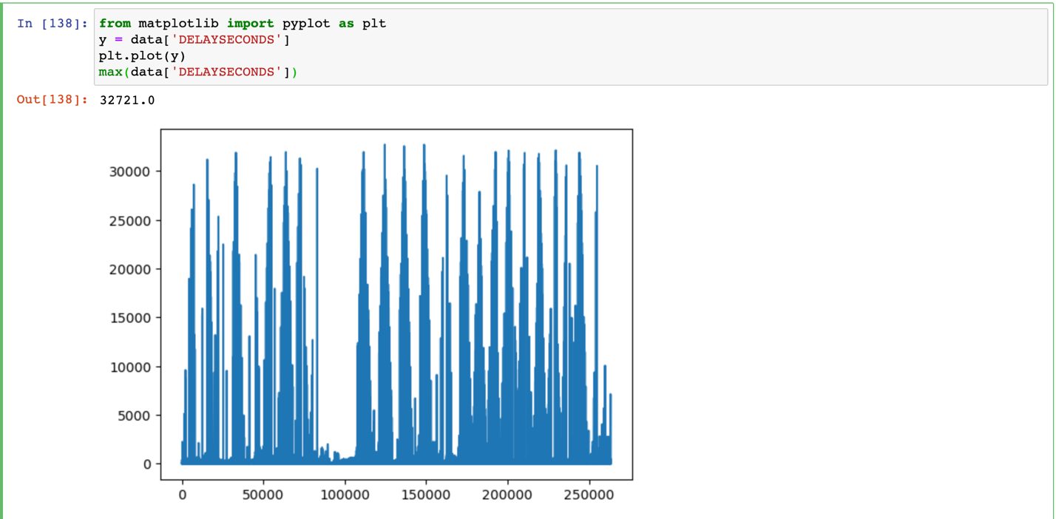**Figure 6:** Spread of delay over time

After separating by train, nearly all trains showed significant delays at points in time. Only trains 308, 309, and 310 did not show delays of more than an hour. If we take train 104 as an example and filter by times the train reported a delay of more than 10,000, we can see that this only occurred 114 times, which is .84% of the total data entries. Most of these delays of more than 10,000 occurred early in the morning (e.g., 2 am), which is the time of day MARTA trains don’t normally run. It’s not clear how exactly MARTA calculates the delay, as there is not documentation, so perhaps this delay is due to not having trains running 24/7.

On top of this, not every train reaches every station every day. Some days, especially earlier on in our data collection in February, certain trains have very peculiar traveling routes, often skipping certain stations in their routes while still visiting stations later on in their journey.  This could be due to a large number of reasons, including API issues, track servicing, train servicing, route closures, crime / intermittent interruptions, or many other potential reasons. Ultimately, MARTA does not publish any reason for this other than the obvious future track closings, so the reason that this might be the case is up for speculation. The good news is that this has seemed to slow down or stop for most of the trains as data approaches current day. This will need to be accounted for in future advanced train-based models, as we cannot assume that trains complete full loops while traveling on tracks.

It’s clear from our initial exploration that the data is not perfect, but that was to be expected at the outset of the project. Since these issues are systemic, and in most cases, issues with MARTA’s own API, there is not too much we can do. Fortunately, our random forest models should be able to handle these issues effectively.

**Model 1: Basic Random Forest**

This model will be conducted on trains 101, 202, 303 and 404 as a baseline of analysis to save time. These trains represent four of the 29 trains that run in MARTA, and a fair split of the two types of trains, with 303 having little to no errors and 404 having a decent number of route errors in the data. These trains also provide a good baseline for each track, with 101 being on the blue track, 202 being on the green track, 303 being on the gold track, and 404 being on the red track. In the final model, whichever models we end up going with will be used on all trains, these are just meant for an example of analysis. Results will vary in the final model based on both new data and the different trains which are used. Keep in mind that we will only be predicting delay time in seconds with this model, which in our final product will then be applied to the standard travel times of each train. So, for example, if you have to travel from point A to point B which would normally take 5 minutes, given a predicted delay of 50 seconds, we would then assume the trip would take 5 minutes and 50 seconds in total.

Each model was run with 1000 trees and a max depth of 20. This was all run using the sklearn.RandomForestRegressor module. The result for each train is printed below.

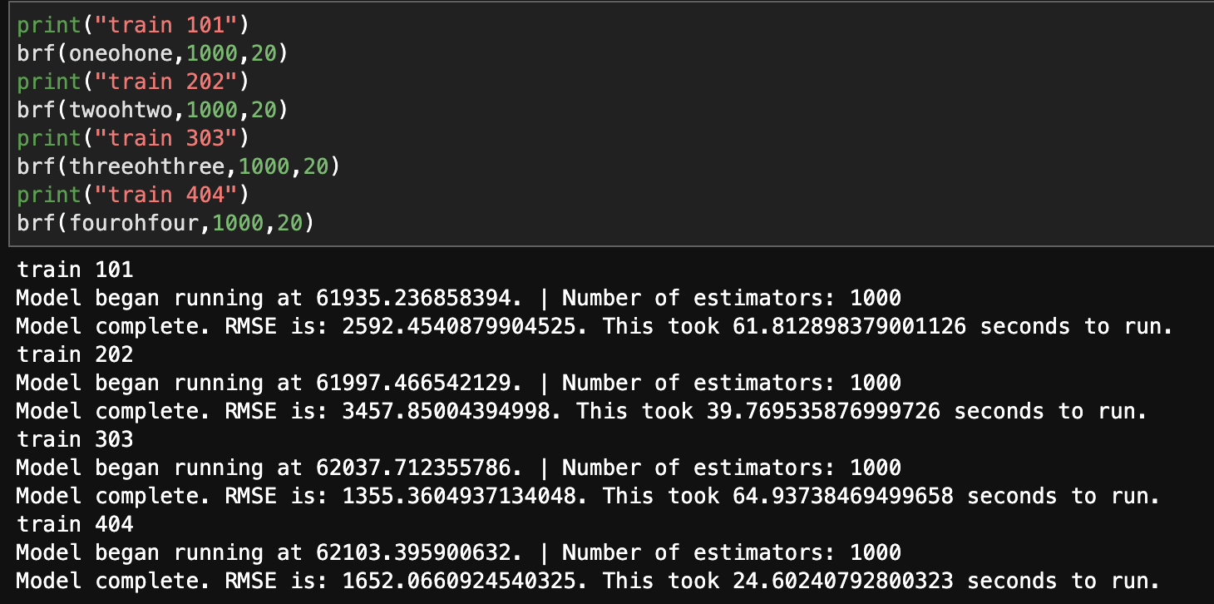 **Figure 7:** Code for Random Forest Regressor

Due to the high variance in the dataset, results such as this can be expected. This can be seen in figures 2 through 5 which are presented below.

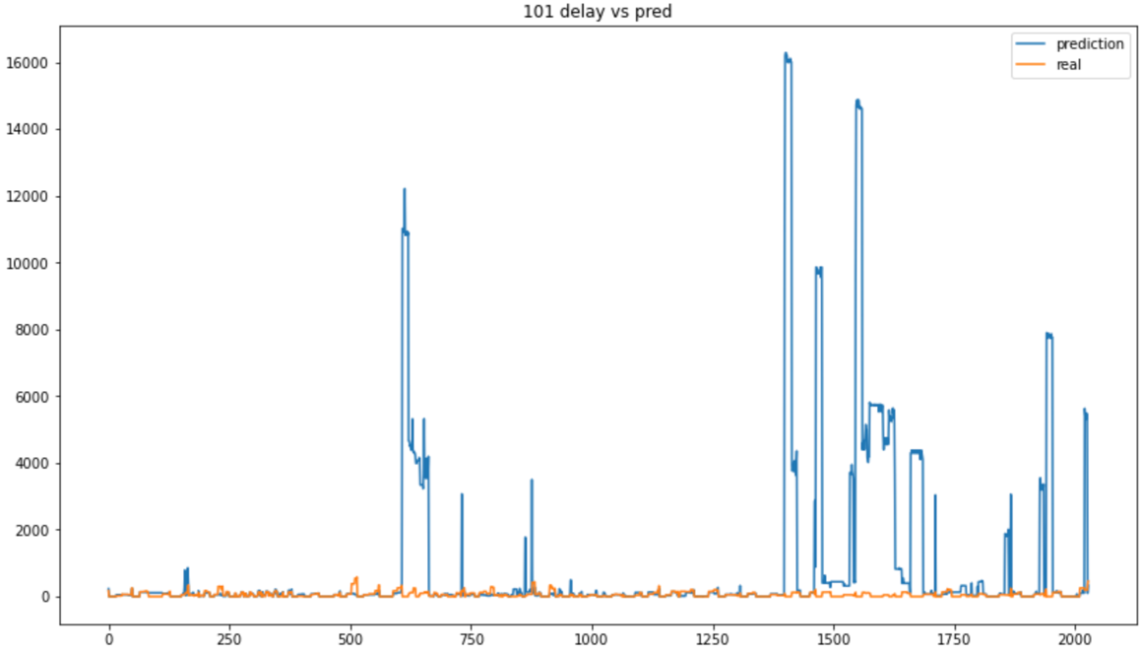 **Figure 8:** Train 101 predictions vs actual values

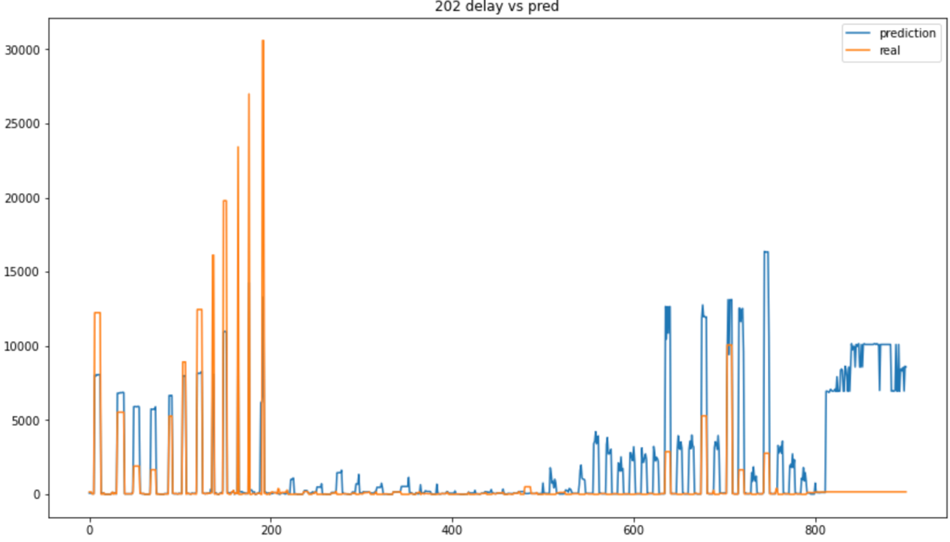 **Figure 8:** Train 202 predictions vs actual values

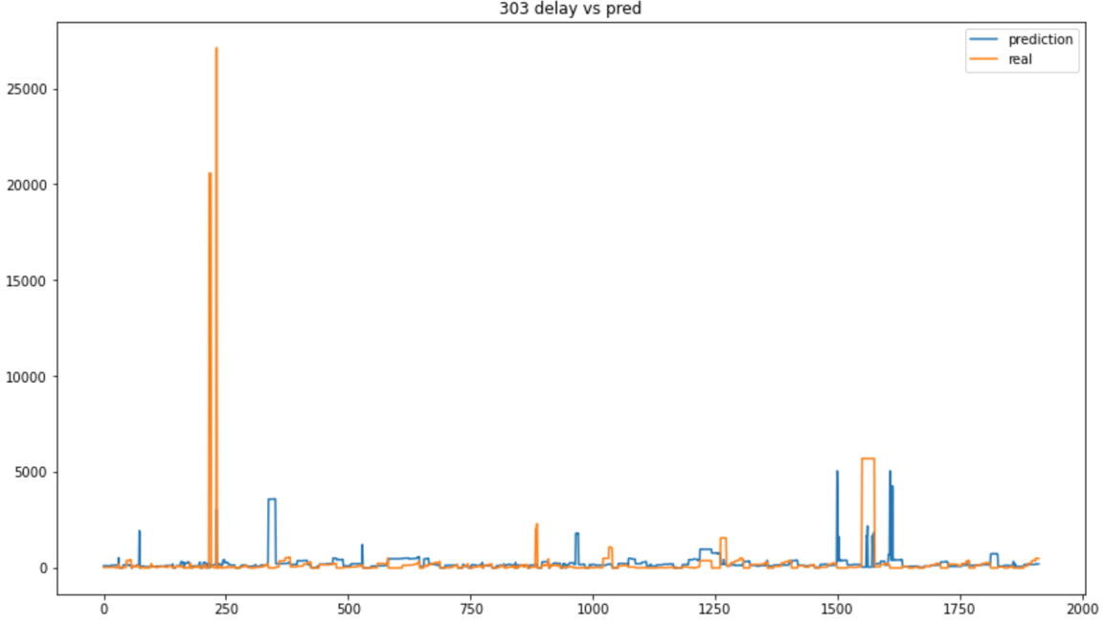 **Figure 8:** Train 303 predictions vs actual values

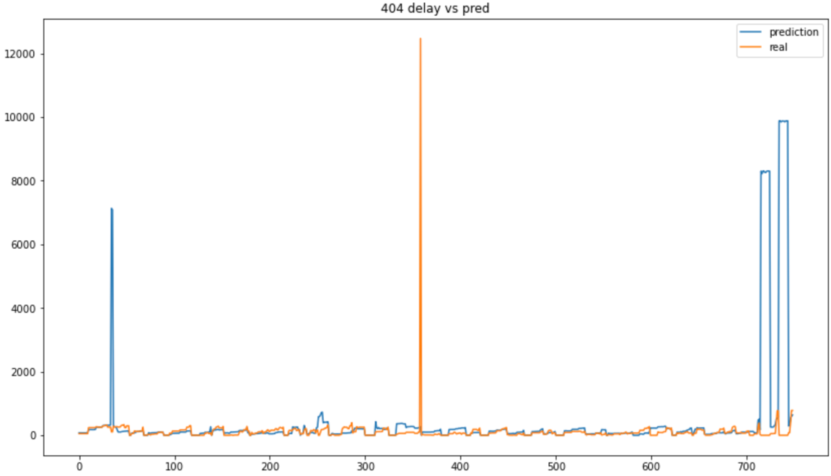

**Figure 10:** Train 404 predictions vs actual values

Due to the high variation in the original data, we believe that there are opportunities to explore other types of models. Additionally, it might be worth examining if there are train (or line) specific models that would perform better in the future. Because of the poor performance of the above model, we also wanted to explore if a random forest classifier for if there are delays > 1 minute or not are worth examining. We set this up the exact same way, only adding a column to determine if that row’s delay is > 60 seconds or not. This would allow us to minimize some of the extreme outliers that seem to be biasing our models. Ultimately, fitting the same model this way seems to work significantly better than what we expected prior. One interesting tidbit is that this new conglomerated model seems to work better on the trains which worked worse for the previous one. 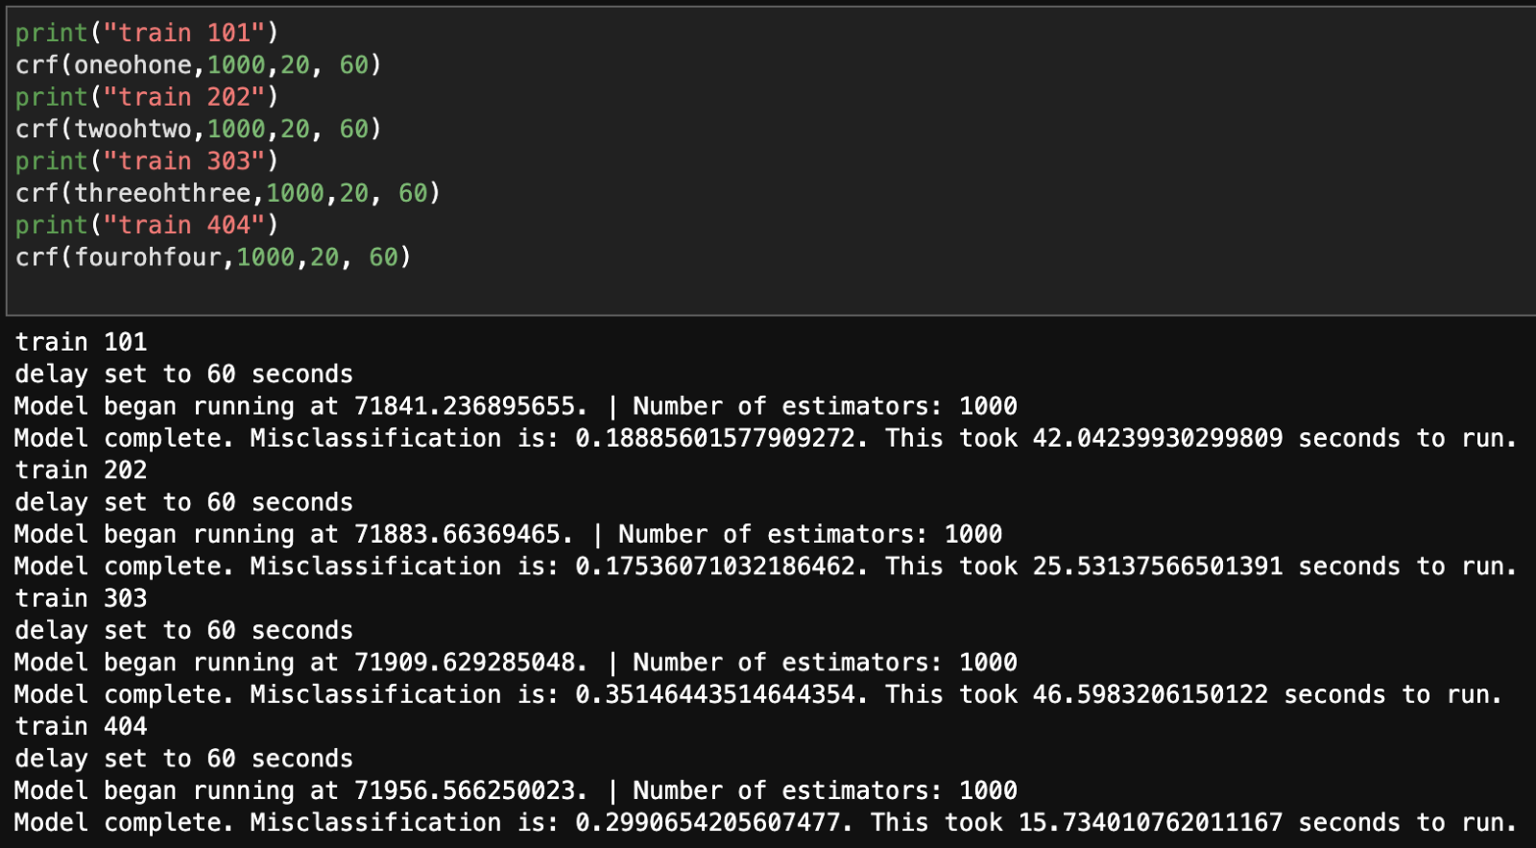**Figure 11:** Code for Random Forest Classifier

**Model 2: Classify short and long delays**

Since there is a large variance in the delays for each train, there could be value in classifying whether a delay will be above or below a certain threshold. Most delays were under one minute, so that will be used as the threshold. A binary variable was created to categorize each row, with ‘0’ being for delays under one minute and ‘1’ for delays over one minute. The number of observations in each class can be seen below. Since the classes are roughly similar in size, we don’t have to worry about class imbalance.

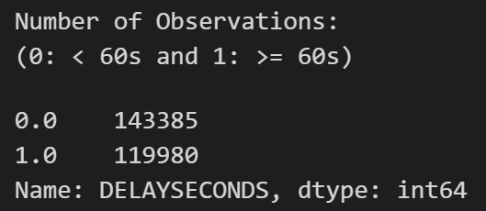

**Figure 12**: Number of data points for each category (<60, >=60)

The independent variables that will be used are the weather, traffic, and train identifier variables. Since they are all not numeric, one-hot-encoding will be used to encode the categorical variables, and then scaling will be done to standardize each variable. This will all be completed with Scikit-Learn's Preprocessing module. The preprocessing steps that were used can be seen below.

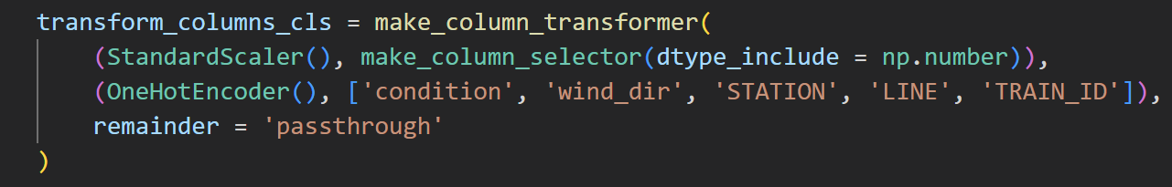

**Figure 13:** Data preprocessing for Gradient Boosting Classifier

The classifier that will be used is the Gradient Boosting Classifier from Scikit-Learn. Of all the models tested, this classifier had the best results. Different values of ‘n_estimators’ and ‘max_depth’ were tested to increase the accuracy of the model. The best model used 1000 estimators and had a max depth of 7, with the setup for the model shown below:

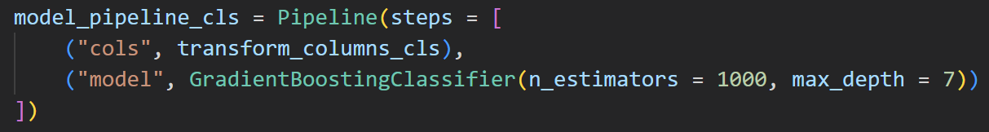

**Figure 14:** Gradient Boosting Classifier model

In order to test the efficacy of the model, we did a train-test split on the data, with 75% of the data in the training set and the rest in the test set. The model was trained on the training set with a lag of 7 days, with a run time of around 25 minutes. When the model was used to predict results on the test data with a lag of 7 days, we produce results that look like this:

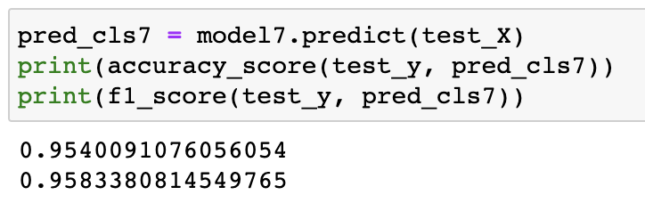**Figure 15**: Accuracy for model on test set

The accuracy and F-1 score was very good for this model, which encouraged us to make this our main model for predicting delays. Since the gradient boosting classifier also has a function to predict the probability of each class, we also included this in our final function, since users might want to see the percent change their train is delayed. We also wanted to test the model’s accuracy for the data with lags of 1 to 6 days. The results for those alternative models were less promising and are shown below.

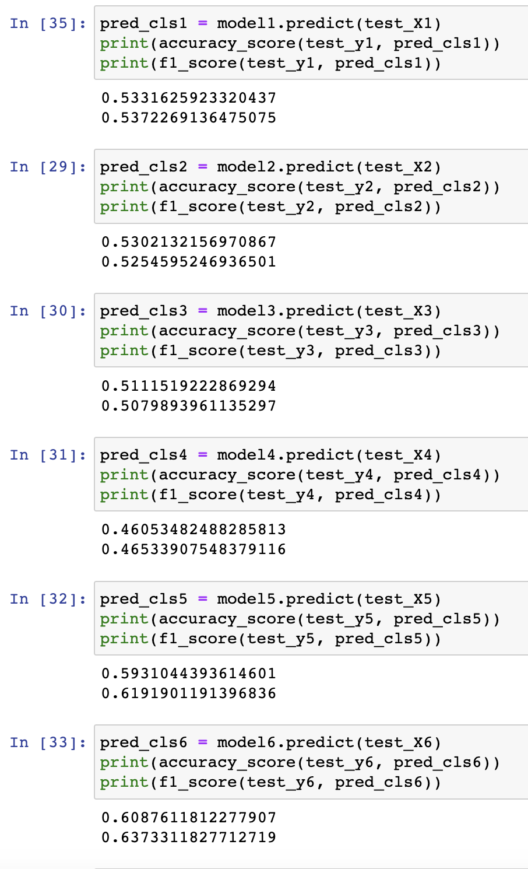

**Figure 16**: Accuracies for model on data with lags of 1 to 6 days

The lack of success for the other models compared with the 7-day model was a little perplexing. However, since the 7-day model performed extremely well, we will just use that as the prediction model.

The Gradient Boosting Classifier seemed to do a good job deciding whether a particular stop would have a delay of over 1 minute. This could be valuable since many would consider a delay of under one minute to be a minor inconvenience and not as impactful as a more substantial delay.

1. Property Evaluation

In this section, we look at some properties of the model. As previously shown, the accuracy on the testing data was .954, but we can visualize the confusion matrix generated by the model below:

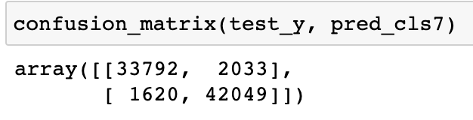

**Figure 17:** Confusion Matrix for the 7-day model

Of the 79,494 data points in the test set, 75,841 were classified correctly. The relative balance between 0s and 1s is also evident from the confusion matrix. Overall, impressive performance from the model. We can also look at the feature importance scores to see which variables have the most impact on the delay time. For sklearn’s GradientBoostingClassifier model, the sum of all feature importance scores is 1, which means that the most impactful variables should have feature importance values between 0.1 and 0.2. Due to the need to one hot encode all the non-numeric variables, 112 different feature importances were created. When the feature importance scores were extracted, these were the most impactful variables:

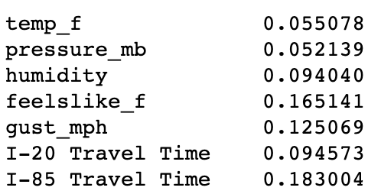

**Figure 18:** Largest feature importance variables

These were all the variables with a feature importance of greater than 0.05. Both traffic variables are present here, with I-85 travel time being the most important of all the variables. This is no surprise, as anyone who has been on I-85 knows its importance to traffic conditions in Atlanta. Since we used the traffic variables as a proxy for rush hour conditions, it seems like that has an effect on the delays of the trains. Perhaps when the number of riders is high at rush hour, the trains take longer to load passengers and end up delayed.

We also see 5 weather related variables present in the top 7. It’s no surprise that weather affects the delays, whether it be due to increased ridership, or potentially poor weather conditions slowing down the trains. Regardless, it’s good to see weather variables among the most important, which further justifies including them in the dataset.

We can also look at the variables deemed to be the least important, shown below:

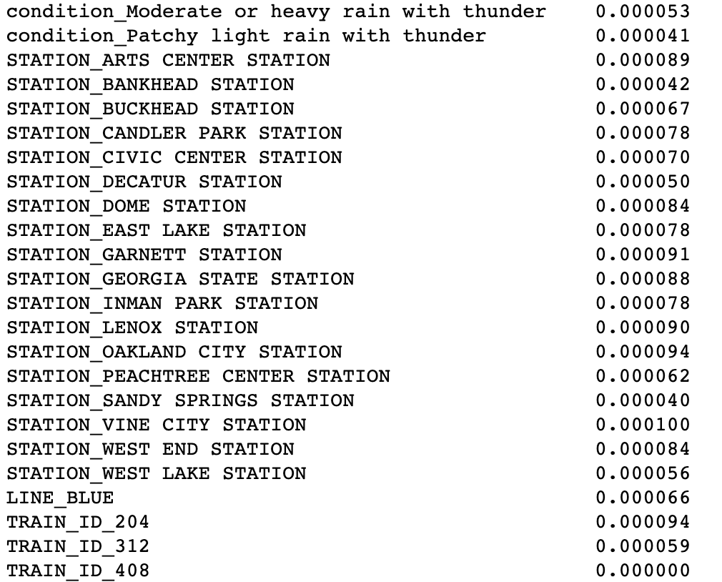**Figure 19:** Smallest feature importance variables

Most of these are features of the trains or stations. This shows that the actual train or the stations themselves do not have too much of an impact on the delays. We can assume that, for instance, there isn’t a station that takes a long time loading the passengers, sparking delays. Furthermore, the trains themselves do not cause any delays, which means that the delays are probably independent of the line the train is on. Obviously, there are instances where a line is delayed or shutdown, such as when the red line was undergoing repairs back in late February. There are also weather variables present, which is a little surprising. However, there were very few instances of these particular weather conditions, so this rarity is a likely explanation for their low relative feature importance.

Overall, these feature importance values give us valuable insight into what the model believes causes these delays. It is also key to justify the inclusion of the other data sources in the model, as the weather and traffic variables proved to be important.

1. Front-end Visualization

In order to visualize our results, we took a two-pronged approach. The first approach was creating a Tableau map showing all trains lines and the current location of each train on the line. Since Tableau can create extremely appealing visualizations easily, this was an easy choice for us. The main drawback to the Tableau approach was that it cannot directly interface with the Python script. The map would need a scheduled update to synchronize with the scheduling of the script, which means it may not be the best option for auto-updating via a web app. To remedy this, we also decided to use folium in python to create a second map. More details on both maps are given below.

**Tableau:**

The first prong of our visualization approach was developed using Tableau Public. There were initial troubles with creating a data model that successfully layered the locations/routes of the stops with the real-time locations of the trains. To have more control over various aspects of the visualization, we created an API-based custom map using a tool called Mapbox which can be seen [here](https://api.mapbox.com/styles/v1/samcourson/clfsifjge004y01qf2jp56fl0.html?title=view&access_token=pk.eyJ1Ijoic2FtY291cnNvbiIsImEiOiJjbGZzYjhlcXMwNDl0M2NzMDNhcmpmamI3In0.1kYYlBQzLD6tQODkGIjGuQ&zoomwheel=true&fresh=true#11.89/33.77185/-84.35201). This map is used as the background layer for the Tableau visualization, but it does not require a Tableau data model. Once this was implemented, it was quite simple to overlay the locations (latitude/longitude) of the trains onto the custom map background.

Below is a current version of our front-end dashboard. The Mapbox map sits in the background, and the train locations sit on top as indicated by the train icons. The train icons are coded to show up as red when delayed, otherwise they show up as green to indicate no significant delay. There is also filtering functionality that allows users to drill down into line color and direction. The final important aspect is the tooltip of the visualization, which displays important information like line color, direction, train ID, and delay status when a user hovers their cursor over a specified train icon. Overall, despite some of the drawbacks mentioned earlier, this visualization is aesthetically pleasing and grants the user a lot of functionality.

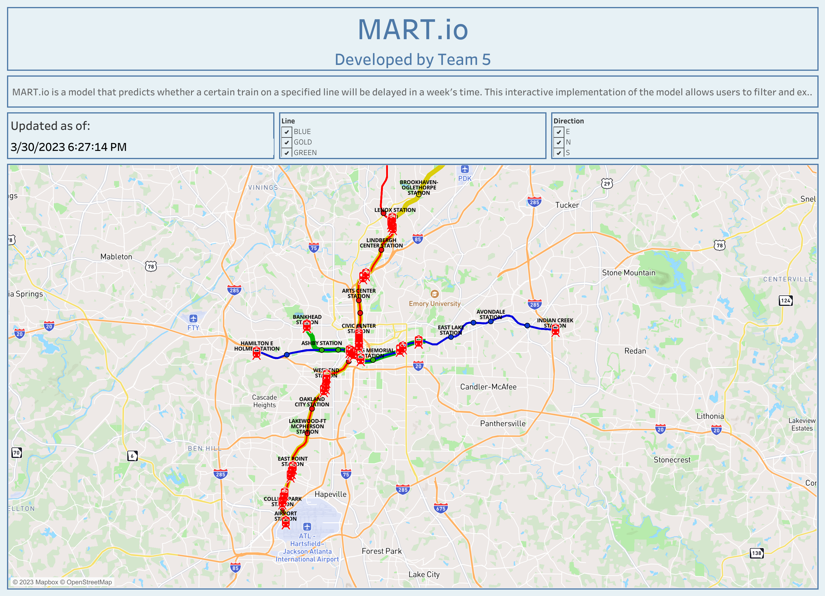**Figure 20:** Tableau map with all train lines present

**Folium:**

A second map was created using the folium package in python. This map was similar to the Tableau, except it runs a single train and line combination at once. The map was embedded in a function which takes the line color and train ID as parameters. Inside this function, data is generated from the three APIs, meaning the map uses real-time information. The data generated is filtered by the parameters of the function, until it only contains data for the train line and train ID specified. This data is then run through the model to generate a set of predictions, both a binary prediction for delayed/on-time, and a predicted percent change the train is delayed/on-time. Using the predictions, we generate the map. Stations with a green circle represent a train that is on-time, while a red circle represents a train that is delayed. The below image represents the results of running the function for train 101 on the blue line. As you can see, all stations are predicted to be on-time for this particular train.

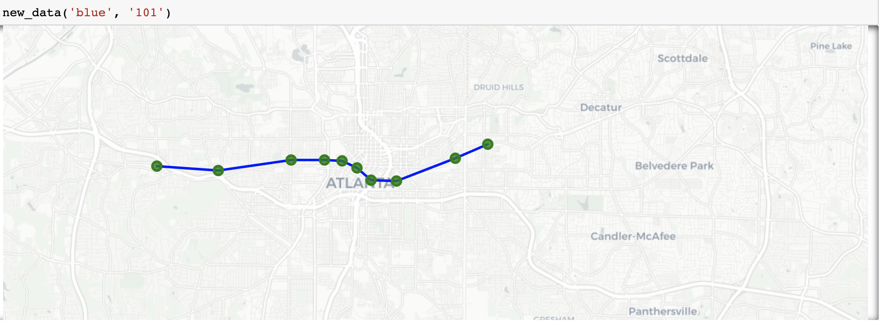**Figure 21:** Output of function for blue line, train 101

We also have a popup that appears when a station is clicked on. This popup contains the station name, the percent chance it is on time, and the percent chance it is delayed.

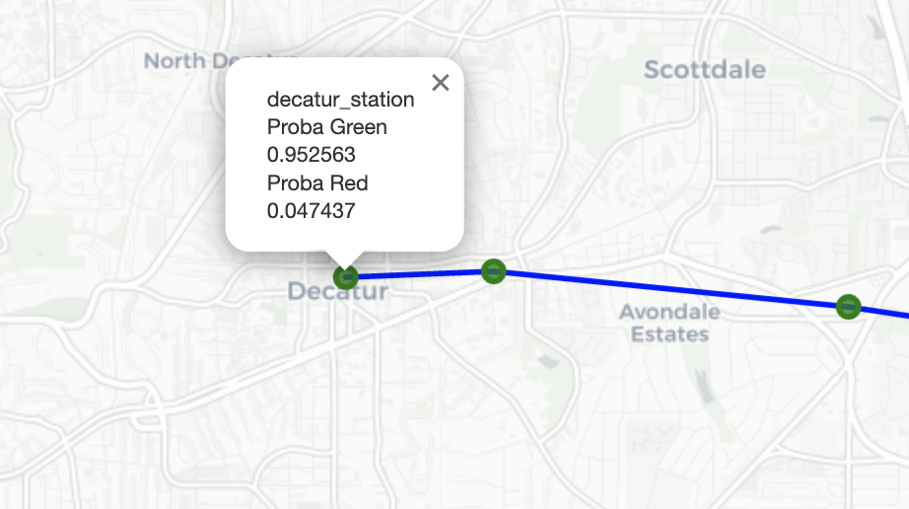

**Figure 22:** Popup showing probabilities for blue line, train 101

**Flask Server:**

We wanted to deploy the function with the folium map on a web server to allow users to input their own values and generate predictions. We set this up using Flask. Flask generates a local web server, which allows us to accomplish our goal. Below is what the flask server looks like.

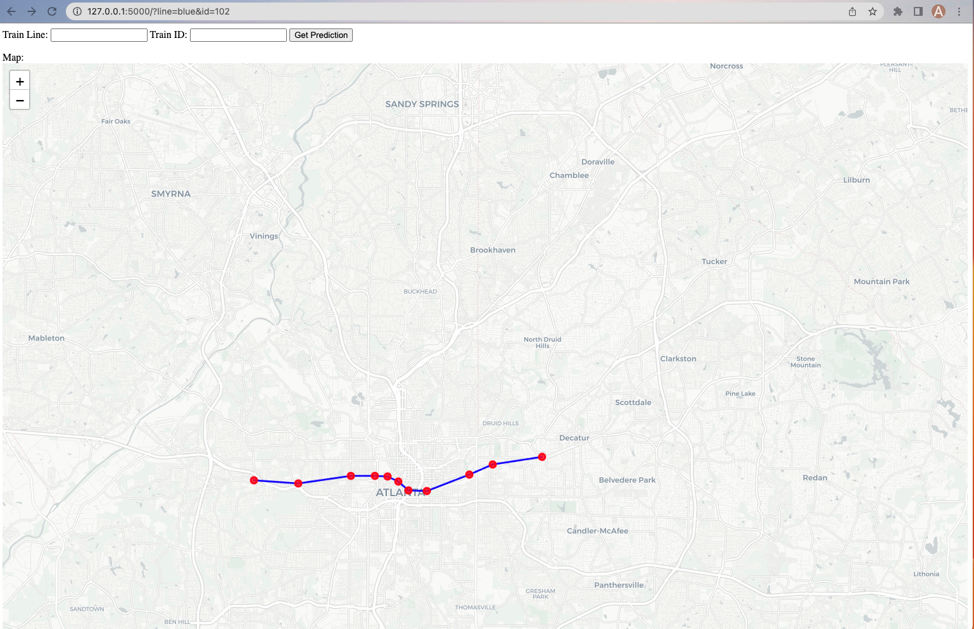

**Figure 23:** Example of the web server interface and results when blue, 102 are inputted

There are two boxes to enter input, and a button to generate the map. Unfortunately, efforts to move the flask server to a website that can be accessed by anyone were unsuccessful, due to issues with the MARTA API that we will discuss later in the conclusion section.

1. Conclusion and Future Work

**Conclusions:**

In the scope of the project, we analyzed the network of Atlanta MARTA and have attempted to predict the delay in the train network at each station. To do this, we leveraged MARTA’s RESTful API, proceeded to clean, and extract value out of the dataset and deployed an ensemble tree Model to predict the delay in train arrivals at stations at multiple time intervals. The Model that proved most efficient for our prediction was the XGBoost model. We observed the most success in prediction accuracy when forecasting delays a week out within each other. This can imply a strong weekly trend in train patterns and scheduling. After a thorough investigation of the modeling properties, our project was scaled to have an interactive interface, through two methods. The first method was a Tableau Dashboard which leveraged historical data, while the second approach was to use the folium package in python and create a web server built on Flask. After experimenting and analyzing the deployment capabilities, we decided to Tableau Dashboard as the interface for customer interactions.

**Future Research:**

The project holds a lot of opportunities for future research in the space of public transportation as well as potential APIs that can run on top of the current system to extract more value out of the project.

1. One clear area of future research would be to identify factors which can capture trend within day 1-6, to further improve the prediction accuracy of our model. Potential ideas and data sources that can be utilized for these include weather data, using an API as well as event data, around the MARTA station locations. These can be strong predictors in understanding how likely trains are to be delayed from each station depending on the aforementioned factors.
2. A potential step in making the public transportation system more predictable would be to expand the model to include Bus service lines. With most places in Atlanta not accessible purely through trains, people who rely on public transportation are likely to use a combination of trains and buses to reach their destination. By integrating Bus routes to the project, we will be able to cater to an even wider set of audience.
3. Integration of Google maps to find the shortest distance path optimized for amount for money spend. With MARTA being the most economical mode of transportation, if we can integrate google maps into our product, we will be able to suggest the best combination of travel options optimized for time and money. We will also be able to provide customized travel recommendations to our customers, when they provide their required time of arrival, as a combination of MARTA train, BUS, walking and projected fee from 3rd party services (Uber, Lyft, Lime).
4. Provided that we have solid proof of concept with the expansion in the points above, we will be able to scale the product to other public transportation services all over the country.

**Customer Discovery:**

There is a set population of customers, that would be the primary target of our product.

1. Regular Marta commuters: Regular MARTA commuters are primarily folks who are trying to get from point A to point B in a time bound fashion. This includes a large group of the population who travel to their office locations in the morning. This is the prime population, who would benefit the most from our service. To most of this population, the opportunity cost of not reaching their office in time while waiting for the train to arrive is not worth it. Hence, they are very likely to use our product beforehand and identify if the train will arrive on time at the station.
2. Tourists: A large number of the tourists are not aware of the MARTA transportation system and the ease of its access. Through our product, we will provide an easily accessible interface of different train stations, predicted delays and arrival times as a function of delay and departure times. The value provided to the tourists in this regard is more in terms of an interactive interface to the public transportation system of Atlanta which make their travel and scheduling plans much easier.

**Revenue Streams:**

The major revenue Stream for our product will come from 2 categories.

1. **B2B** – One potential stream of revenue for our product is to sell our product and services to a company. This can be either as the whole product or as a service. One potential stream would be to sell the whole product to MARTA or contract the service to MARTA and produce a stream of revenue from MARTA depending on the Average monthly users.
2. **B2C** – In this category, our product would be converted to a Mobile application and a web application, and we would generate revenue through 2 primary channels.

**Ad Revenue:**

We will monetize the banner space in the web and mobile application, and this will provide a stream of revenue through views and click rate.

**Subscription Model:**

We can introduce a subscription model for our product, where the users pay an annual or monthly subscription fee for the product. We will primarily be targeting the regular commuters for this revenue stream. We can also enter into a contract with MARTA to bundle our monthly subscription with MARTA passes at an attractive rate.

**Roadblocks and Difficulties:**

Over the project duration there are a few Roadblocks that we have experiences which should be kept in mind while expanding the scope of the project.

1. Reliability of Data sources: During the Data pull we noticed several inconsistencies with the data from the MARTA API. There were multiple days when one or more of the data sources did not work. An example of this was when the MARTA API did not work after the time change, leaving nearly 48 hours of data unaccounted for. Furthermore, since the pull was being done on a physical computer, internet unreliability also caused small gaps in the data.
2. Future accessibility of data: MARTA API has recently changed its SSL security certificate. This makes the data pull from the website impossible, unless ‘verify = False’ is specified. Since the API is not MARTA’s main focus, they are not particularly helpful in resolving this issue. This impacted the visualization component of the project as one of our visualization ideas with folium package in python and creating a web server built with Flask was no longer feasible. The hosting site did not want to expose themselves to any cybersecurity risks, so they would not allow the ‘verify= False’ parameter to be used. If MARTA fixes this issue, the web server can be a reality, but until then, we must shelve it.
3. Another issue is that the Google Maps API used to generate the traffic data is a paid API, costing $10 per 1000 pulls, with the first 20,000 pulls free each month. We therefore must take into account this cost, should our model accrue enough interest to surpass the 20,000 pulls per month threshold. With a good monetization scheme, this wouldn’t be too much of an issue, but until then, we must be careful to avoid a hefty charge.
4. References

Bollinger, C. R., & Ihlanfeldt, K. R. (1997b). The Impact of Rapid Rail Transit on Economic Development: The Case of Atlanta’s MARTA. *Journal of Urban Economics*, *42*(2), 179–204. <https://doi.org/10.1006/juec.1996.2020>

Gupta, M., & Shrestha, R. (2017). Gradient Boosted Machines for Transportation Delay Prediction. *Transportation Research Part C: Emerging Technologies*, 85, 438-454.

Macfarlane, G. S., Garrow, L. A., & Moreno-Cruz, J. (2015). Do Atlanta residents value MARTA? Selecting an autoregressive model to recover willingness to pay. *Transportation Research Part A-policy and Practice*. <https://doi.org/10.1016/j.tra.2015.05.010>

Peters, J. A., Emig, B., Jung, M., & Schmidt, S. (2005). Prediction of Delays in Public Transportation using Neural Networks. In *Computational Intelligence for Modelling, Control and Automation*. <https://doi.org/10.1109/cimca.2005.1631451>

Tucker, S. (2017). An Analysis of Transportation Demand in Atlanta: How Much Will Atlanta's Proposed MARTA Expansions Increase Ridership? (Doctoral dissertation, Georgia Institute of Technology).

Yener, M. E., & Ercan, M. F. (2019). Boosting the Predictive Accuracy of Subway Train Delay Time. *Transportation Research Part C: Emerging Technologies,* 101, 213- 232.

Zhang, Y., & Haghani, A. (2015). A gradient boosting method to improve travel time prediction. *Transportation Research Part C-emerging Technologies*, *58*, 308–324. <https://doi.org/10.1016/j.trc.2015.02.019>

Shoman, M., Aboah, A., & Adu-Gyamfi, Y. (2020). Deep Learning Framework for Predicting Bus Delays on Multiple Routes Using Heterogenous Datasets. *Journal of Big Data Analytics in Transportation*, *2*(3), 275–290. <https://doi.org/10.1007/s42421-020-00031-y>

Avelar, S. (2008). Visualizing public transport networks: an experiment in Zurich. *Journal of Maps*, *4*(1), 134–150. <https://doi.org/10.4113/jom.2008.1007>

Zeng, W., Fu, C., Arisona, S. M., Erath, A., & Qu, H. (2014). Visualizing Mobility of Public Transportation System. *IEEE Transactions on Visualization and Computer Graphics*, *20*(12), 1833–1842. <https://doi.org/10.1109/tvcg.2014.2346893>

1. Appendix

**Train Data Pull**

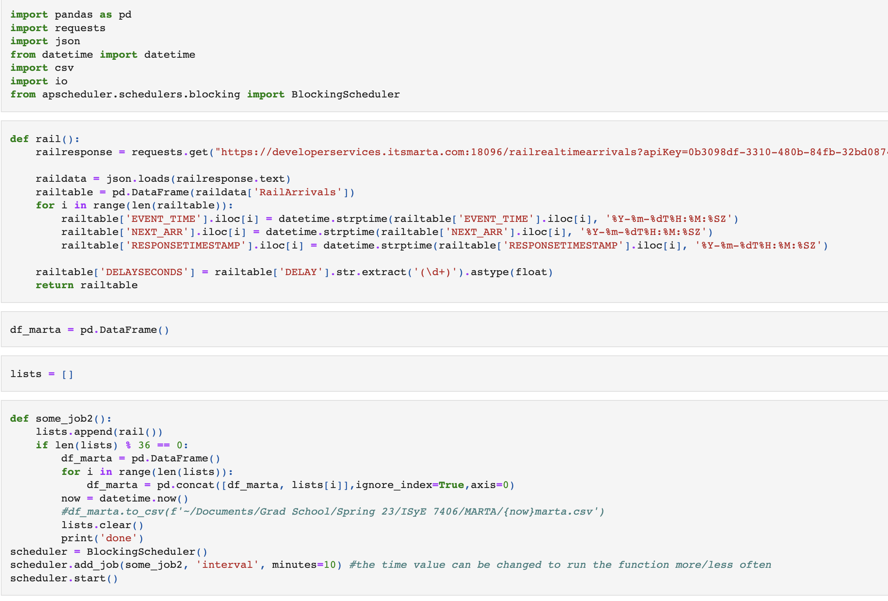

**Weather and Traffic Pull**

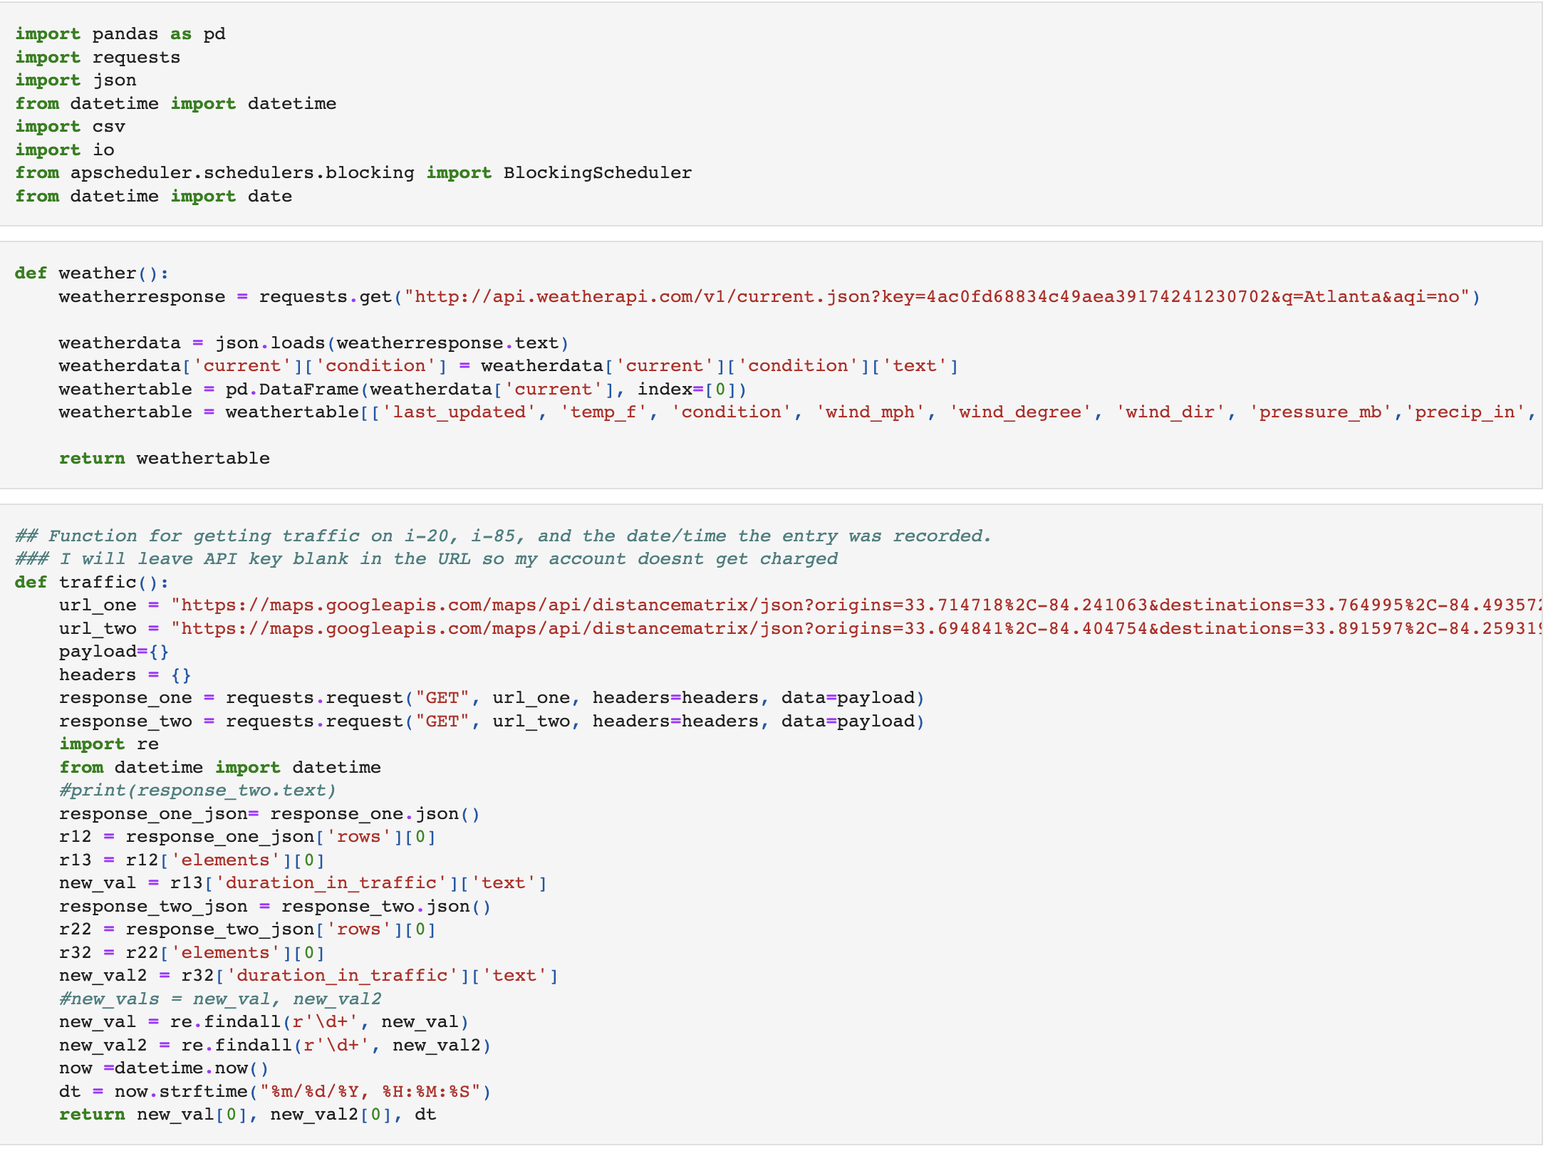

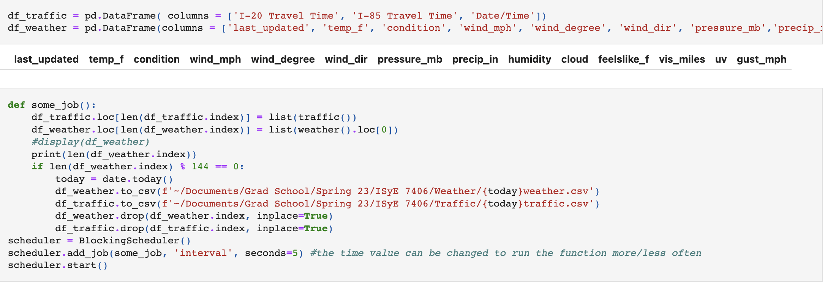

**Model Creation**

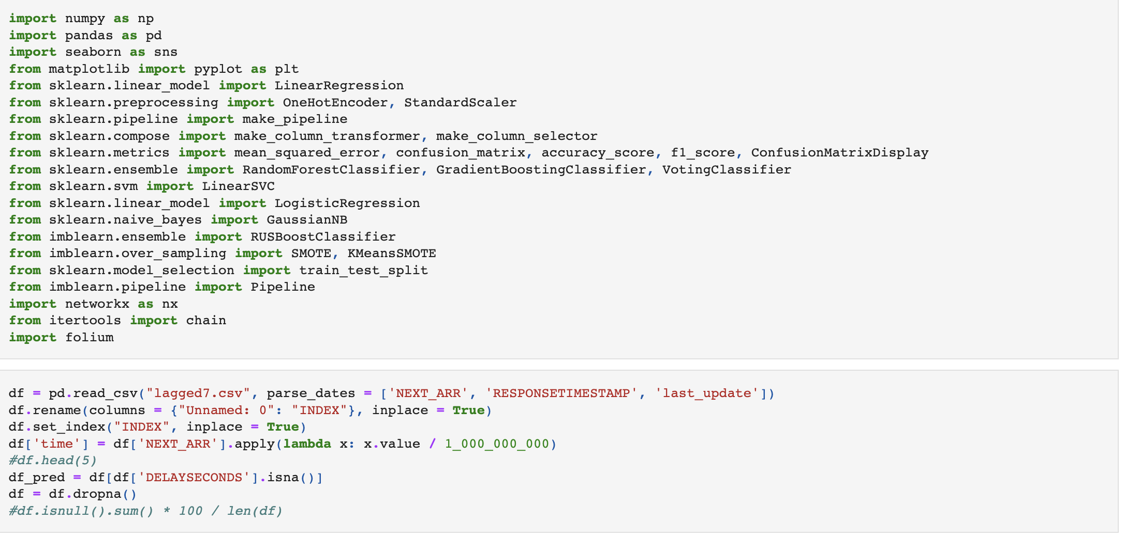



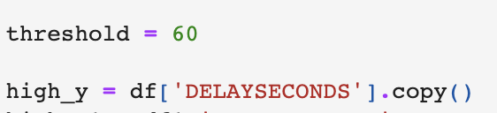

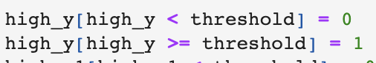



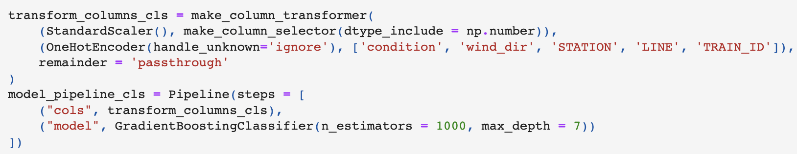



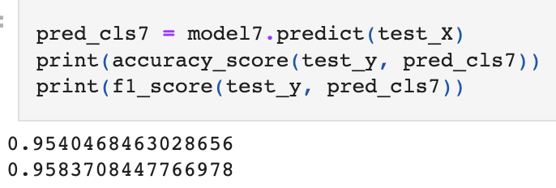





**Code for Generating Prediction Map**

import pandas as pd

import requests

import json

from datetime import datetime

import networkx as nx

import numpy as np

import folium

import pickle

model7 = pickle.load(open('model1.pkl', 'rb'))

def weather():

weatherresponse = requests.get("http://api.weatherapi.com/v1/current.json?key=4ac0fd68834c49aea39174241230702&q=Atlanta&aqi=no")

weatherdata = json.loads(weatherresponse.text)

weatherdata['current']['condition'] = weatherdata['current']['condition']['text']

weathertable = pd.DataFrame(weatherdata['current'], index=[0])

weathertable = weathertable[['last_updated', 'temp_f', 'condition', 'wind_mph', 'wind_degree', 'wind_dir', 'pressure_mb','precip_in', 'humidity', 'cloud','feelslike_f','vis_miles', 'uv', 'gust_mph']]

return weathertable

def traffic():

url_one = "https://maps.googleapis.com/maps/api/distancematrix/json?origins=33.714718%2C-84.241063&destinations=33.764995%2C-84.493572&departure_time=now&key"

url_two = "https://maps.googleapis.com/maps/api/distancematrix/json?origins=33.694841%2C-84.404754&destinations=33.891597%2C-84.259319&departure_time=now&key="

payload={}

headers = {}

response_one = requests.request("GET", url_one, headers=headers, data=payload)

response_two = requests.request("GET", url_two, headers=headers, data=payload)

import re

from datetime import datetime

#print(response_two.text)

response_one_json= response_one.json()

r12 = response_one_json['rows'][0]

r13 = r12['elements'][0]

new_val = r13['duration_in_traffic']['text']

response_two_json = response_two.json()

r22 = response_two_json['rows'][0]

r32 = r22['elements'][0]

new_val2 = r32['duration_in_traffic']['text']

#new_vals = new_val, new_val2

new_val = re.findall(r'\d+', new_val)

new_val2 = re.findall(r'\d+', new_val2)

now =datetime.now()

dt = now.strftime("%m/%d/%Y, %H:%M:%S")

return new_val[0], new_val2[0], dt

def rail():

import warnings

warnings.filterwarnings("ignore")

railresponse = requests.get("https://developerservices.itsmarta.com:18096/railrealtimearrivals?apiKey=e2a5883f-81b4-4965-bd26-95dde75d5adc", verify = False)

raildata = json.loads(railresponse.text)

railtable = pd.DataFrame(raildata['RailArrivals'])

for i in range(len(railtable)):

railtable['EVENT_TIME'].iloc[i] = datetime.strptime(railtable['EVENT_TIME'].iloc[i], '%Y-%m-%dT%H:%M:%SZ')

railtable['NEXT_ARR'].iloc[i] = datetime.strptime(railtable['NEXT_ARR'].iloc[i], '%Y-%m-%dT%H:%M:%SZ')

railtable['RESPONSETIMESTAMP'].iloc[i] = datetime.strptime(railtable['RESPONSETIMESTAMP'].iloc[i], '%Y-%m-%dT%H:%M:%SZ')

railtable['DELAYSECONDS'] = railtable['DELAY'].str.extract('(\d+)').astype(float)

railtable['Latitude'] = railtable['VEHICLELONGITUDE']

railtable['Longitude'] = railtable['VEHICLELATITUDE']

railtable = railtable.drop(columns = ['VEHICLELATITUDE', 'VEHICLELONGITUDE'], axis =1)

#railtable.to_csv('railtable.csv')

return railtable

class Stops:

def __init__(self, id, code, name, lat, lon):

self.id = id

self.code = code

self.name = name

#self.line = line

#self.type = type

self.lat = float(lat)

self.lon = float(lon)

def get_name(self):

return self.name

#def get_line(self):

#return self.line

#def get_type(self):

#return self.type

def get_location(self):

return (self.lat, self.lon)

def create_stations(filename):

df = pd.read_csv(filename)

stops = {} # can also do a list and append each instance to it stops.append(Stops(row['stop_id'], row['stop_code'], row['stop_name'], row["stop_lat"], row["stop_lon"]))

for index, row in df.iterrows():

row['stop_name'] = row['stop_name'].lower().replace(" ", "_")

instance_name = row['stop_name'].lower().replace(" ", "_")

instance_content = Stops(row['stop_id'], row['stop_code'], row['stop_name'], row["stop_lat"], row["stop_lon"])

setattr(instance_content, instance_name, instance_content) # creates a new instance variable on the Team object, using the value of instance_name as the variable name.

stops[instance_name] = instance_content

return stops

x_cols = ['temp_f', 'condition', 'wind_mph', 'wind_degree', 'wind_dir', 'pressure_mb',

'precip_in', 'humidity', 'cloud', 'feelslike_f', 'gust_mph', 'I-20 Travel Time', 'I-85 Travel Time',

'STATION', 'LINE', 'TRAIN_ID']

def new_data(line = 'red', train = '404'):

df_traffic = pd.DataFrame( columns = ['I-20 Travel Time', 'I-85 Travel Time', 'Date/Time'])

df_weather = pd.DataFrame(columns = ['last_updated', 'temp_f', 'condition', 'wind_mph', 'wind_degree', 'wind_dir', 'pressure_mb','precip_in', 'humidity', 'cloud','feelslike_f','vis_miles', 'uv', 'gust_mph'])

df_traffic.loc[len(df_traffic.index)] = list(traffic())

df_weather.loc[len(df_weather.index)] = list(weather().loc[0])

df_traffic['Date/Time']=pd.to_datetime(df_traffic['Date/Time'], errors='coerce')

df_traffic['dt'] = df_traffic['Date/Time']

df_weather['last_updated'] = pd.to_datetime(df_weather['last_updated'])

df_weather['last_update'] = df_weather['last_updated']

comb = df_weather.merge(df_traffic, left_index=True, right_index=True)

comb = comb.set_index('dt')

rails = rail()

rails = rails.sort_values(by = 'EVENT_TIME').set_index('EVENT_TIME')

rails.index = pd.to_datetime(rails.index, errors = 'coerce')

data = pd.merge_asof(rails, comb, left_on = 'EVENT_TIME', right_on= 'dt',direction = 'nearest',tolerance =pd.Timedelta('10 min')).dropna()

X = data[x_cols]

pred = pd.Series(model7.predict(X))

predgreen = pd.Series(model7.predict_proba(X)[:,0])

predred = pd.Series(model7.predict_proba(X)[:,1])

XP = X.merge(pred.rename('Predicted'), left_index=True, right_index=True)

XP = XP.merge(predgreen.rename('Proba Green'), left_index = True, right_index = True)

XP = XP.merge(predred.rename('Proba Red'), left_index = True, right_index = True)

XP = XP[['STATION', 'LINE', 'TRAIN_ID', 'Predicted', 'Proba Green', 'Proba Red']].drop_duplicates()

XP['Color'] = np.where(XP['Predicted'] == 1, 'Red', 'Green')

#XP2 = XP.loc[(XP['TRAIN_ID']==train) & (XP['LINE']==line)].drop(columns = ['TRAIN_ID', 'LINE', 'Predicted'], axis =1)

XP2 = XP.loc[XP['TRAIN_ID']==train].drop(columns = ['TRAIN_ID', 'LINE', 'Predicted'], axis =1)

XP2['STATION'] = XP2['STATION'].str.lower().str.replace(' ', '_')

XP2['Color'] = XP2['Color'].str.lower()

XP3 = XP2.set_index('STATION')

XP5 = XP3.copy()

XP3 = XP3.drop(columns = ['Proba Green', 'Proba Red'], axis =1)

XP5 = XP5[['Proba Green', 'Proba Red']]

#print(XP5.loc)

print(pred.value_counts())

nodes = create_stations("data/MARTA_Stops.csv")

edges = pd.read_csv("data/MARTA_edges.csv")

#print(list(XP3.index))

for k in list(nodes.keys()):

if k not in list(XP3.index):

del nodes[k]

#display(nodes)

#display(edges)

edges = edges.loc[(edges['source'].isin(list(XP3.index))) & (edges['dest'].isin(list(XP3.index)))]

G = nx.from_pandas_edgelist(edges, 'source', 'dest', edge_attr=['duration', 'line'])

weights = {edge: duration for edge, duration in nx.get_edge_attributes(G, 'duration').items()}

color = {edge: line for edge, line in nx.get_edge_attributes(G, 'line').items()}

#display(edges)

# pos = {}

# for node in nodes:

# pos[node] = (nodes[node].lon, nodes[node].lat)

# plt.figure(figsize=(10, 10))

# nx.draw_networkx(G, pos=pos, with_labels=True, width=list(weights.values()))

m = folium.Map(location=[33.7490, -84.3880], zoom_start=12, tiles = "CartoDB Positron") # set the initial location and zoom level of the map

#print(list(G.edges()))

for edge in G.edges():

u, v = edge

folium.PolyLine(locations=[(nodes[u].lat, nodes[u].lon), (nodes[v].lat, nodes[v].lon)],

weight=weights[edge]**(1/2)*2, color = line, zindex = 1).add_to(m) # add edges as polylines with weight proportional to duration

for node in list(XP3.index):

XP4 = XP3.loc[node].to_json()

XP4 = XP4[10:]

color = XP4[:-2]

s= pd.Series(XP5.loc[node]).to_string()

folium.CircleMarker(location=[nodes[node].lat, nodes[node].lon], popup=(node+ ' '+ s), radius= 5, color = color, fill_color = color, fill_opacity = .8).add_to(m) # add markers for each node

#XP4 = XP3.loc['airport_station'].to_json()

#XP4 = XP4[9:]

#print(XP4[:-1])

m.save('map.html')

return m

new_data('blue', '102')

**The raw files can be found at** [**https://github.com/an-crawford/mart.io**](https://github.com/an-crawford/mart.io)